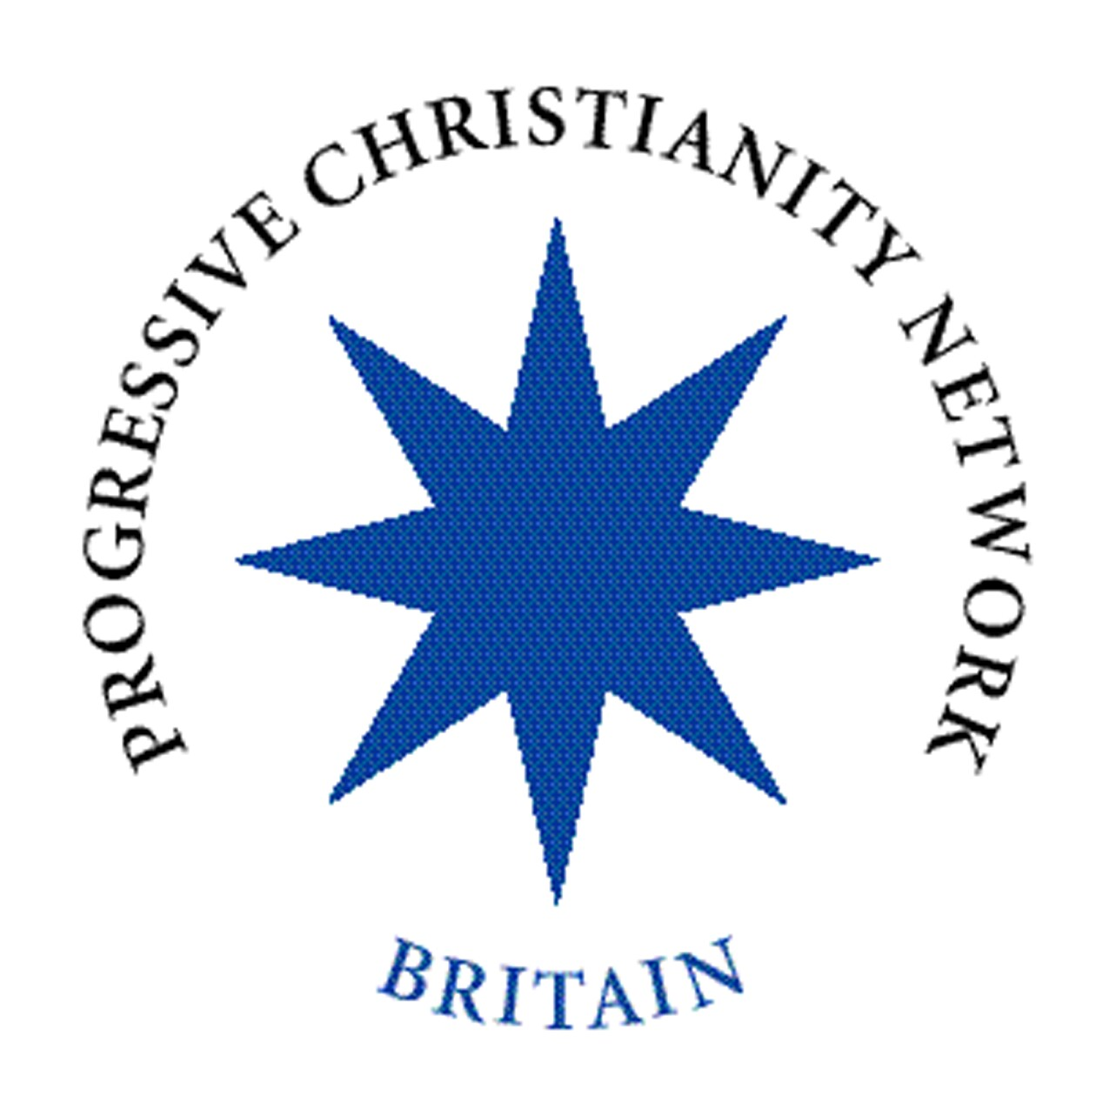
Strategy 2012 – 2015
What have we achieved? – What next?

Strategy Review 2008-2011

Aim 1: Supporting progressive Christianity nationwide and Developing of a coalition of theologically open Christian organisations
In response to statements made at the last Strategy Review [December 2008 - January 2009] concerning the need to continue developing a coalition of like minded-progressive organisations as being crucial for both expanding the boundaries of theology and 'to be heard' by more people, the media, etc, members of the Management Committee have continuously attempted to build links with other related organisations. Ideas discussed and shared with 'partners' have included possible co-stands at events such as Greenbelt; organising major public meetings with well-known speakers; etc. Although progress has not been as rapid as anticipated the development of a coalition of theologically open Christian organisations is an on-going necessity and commitment. An example of developing links was the participation of Hilary Topp [Student Christian Movement] and Roberta Rominger [General Secretary of the URC] in the 2011 AGM. While a few 'natural' partner organisations have been very keen to develop stronger links others have been reluctant for a number of reasons [e.g. fear of loss of organisational identity by publicly working more closely with partners; some single-issue organisations being prepared to work co-operatively only on the single issue and not on a broader progressive front; etc]. Overlapping Aims 1 and 2 is the very successful continuation of the Together in Hope publication partnership. Following the success of the original volume 'Together in Hope' the publication partnership has now gone on to publish three study guides in what will be a continuing series.

Aim 2: Development and resourcing of members and local groups
PCN Britain is an organisation of individual members, many of whom then meet in local autonomous groups that come under the banner of PCN Britain. However, members of the Management Committee have continued developing and resourcing the local groups as a primary tool in supporting individual members. As a result, the numbers of local groups and individual members have both grown by some 40% over the three years under review. New DVDs have been purchased for loan through the newly established 'DVD lending library'. In addition to the regular national events / speakers [e.g. Jack Spong; Marcus Borg; Dom Crossan] a number of Management Committee members, by invitation, now regularly visit local groups to lead seminars, discussions, workshops, etc. The Newsletter continues to be a valuable tool in supporting individual members and groups. The developing web site and regular email updates to members from the Chair, also offer important support.

Aim 3: Administrative support to sustain the Network
Members previously commented on the high quality of support that had been consistently offered. However, as a result of the continuing growth in membership numbers and local groups; range of activities; etc, the Management Committee agreed to increase the number of hours to be worked by the Administrative Assistant. This has been both a necessary and highly productive decision financed by the increase in individual membership.

Other concerns raised in the previous strategy review included the following:
- Management Committee membership was perceived as being top heavy with ‘ordained’ denominationally based members. This has been addressed and now the current Management Committee membership comprises 6 ordained [Anglican, URC and Methodist, 'active' and retired]; 5 lay [Anglican, Methodist, Baptist, Episcopalian, and 1 unattached]. At least 2 members are part of what is known as 'the missing generation' and this offers immense promise for the future of PCN Britain.
- Guidance was requested on how to start a local group, ideas for themes/ programmes, optimum environment, publicising etc. This has been addressed through the production of two guides (available on-line or from the office); one on running a group and the other on running a conference. These remain under review and currently are being updated in the light of experience of the first round of publication.
- Promoting PCN/Open Christianity locally [e.g. local press/radio etc, study days; etc] was suggested. This has been addressed by members of the Management Committee speaking at locally organised / promoted seminars, day workshops; etc. In addition, as part of the promotion of Jack Spong's 2011 visit to the West of Scotland groups, wide press coverage was arranged by local group organisers, including Jack appearing on Scottish television.
- Local ‘hubs’ organising conferences/events etc on a regional basis have been encouraged and some such events have been organised.
- In response to a request that there should be meetings / dialogue between Group Convenors to foster cooperation and cohesion within PCN Britain, three regional meetings were arranged by the Management Committee in 2010.
- There was a suggestion that the newsletter could be offered as a pdf by email to reduce recycling, save postage and allow copies to be made available to a wider church leadership. Pdf copies are now sent to group convenors and the possibility of offering this option to individual members remains under review by the Management Committee.

Strategy directions for 2012-2015

From soundings and submissions [including comments at the 2011 AGM; local group comments; etc] the following points are offered to members for consideration and further comment. Please make any comments that you wish on these and also add any further suggestions to help guide the Management Committee as it plans for the coming 3 year Strategy.

1] Resources continue to be a key issue both for those who remain in church and for those who have left the institutional church but who maintain a progressive Christian lifestyle.
1.1] Although some significant inroads have been made into providing more resources, there is an on-going search for yet more – particularly home grown ‘British’ material, including progressive liturgy and other quality progressive resources.
1.2] When does an alternative Christian worship service (which often uses more progressive, open, inclusive, or even pluralistic theology) really become a progressive Christian worship service because progressive (radical) theologies are being openly proclaimed rather than the classical theologies that are expressed in traditional services? Also, recognising that there are now a number of progressive ‘worship’ groups that may or may not be part of PCN Britain, should we be working with them on constructing liturgies for such meetings / emerging services?
1.3] Short reflective ‘theological’ UK-based Study Guides and papers from both academics and grass roots may be useful as additions to the 'Together in Hope' joint publications. Each of these may address specific issues such as "Where next for Progressive Christianity both theologically and ecclesiastically?"
1.4] Further development of the DVD library.
1.5] Create a postal book lending library.
1.6] To research and then make available by loan or sale progressive Christianity resources from around the world.
1.7] Making more use of ‘e-publishing’ to provide new resources.

Most members ask for more resources, especially those they can use at meetings – so the preparation of any or all of the above remains a vital project.

2] Speaker resources to support local events and regional conferences
2.1] Should PCN Britain seek out suitable speakers/discrete session facilitators to provide a list of UK speakers that local groups may have a chance of affording?
2.2] Would members welcome opportunities to attend regional residential weekends, similar to the current annual St Deiniol’s (Gladstone's Library) model?
2.3] How can PCN improve its offer in terms of conferences and seminars? Are there new formats that we could develop?

3] Membership questions.
3.1] Do you feel your membership is worthwhile? If so what do you most value, if not how can we improve?
3.2] Should PCN Britain aim to increase its membership and if so how might we go about this?

Thank you for your participation in the tri-annual Strategy Review. Your opinions are appreciated and the Management Committee will find them to be very helpful.
Response from members
Please read the above review of the past 3 years and make your comments, so that the Committee can set the strategy for the Network at its planning meeting in October 2011.
This response form is also available on the PCN website. Please return it by post to Andy Vivian, Admin Assistant, PCN Britain, 26 High Street, Newnham, Gloucestershire GL14 1BB or by email to andy.vivian@pcnbritain.org.uk by Monday 3rd October 2011.

Name:

I am / am not a member of a local group

Name of group if applicable:

Strategy agreed for 2008 - 2011 | Are you satisfied/not satisfied with progress?  Please add comments | Would you like PCN to continue with this aim? If so, with what specific targets? | How would you see further developments being resourced?
1: Supporting progressive Christianity nationwide and developing of a coalition of theologically open Christian organisations
2: Development and resourcing of members and local groups
3: Administrative support to sustain the network

Continued overleaf
Planning for 2012 - 2015
Please add comments on the options listed in the section above called 'Strategy directions for 2012-2015'

Please add any further suggestions of your own.
Revenue, particularly in these difficult financial times, remains a challenge to all charities. Do you have any suggestions for raising revenue?

Thank you for taking part in the strategy review.

